St Johns Hall Meadowfield DH7 8RP
The following activities are on at the hall,
Mondays
St Johns Church Play group 9.30 am. (term time)
Pilates with Paul 12.15 pm -1.15 pm. £5 07804 541181
Tuesdays
Hartbeeps 10 am Happy House, 11 am baby beeps, 12.15 pm Baby Bells. 1,15 happy House Contact Abby 07534 018440
7pm-8pm intermediate Ballroom, latin and sequence dancing with Dianne Ross 0776 9632412.
Wednesday
9.30 am Paul’s over 50’s circuits. 07804 541181 (can just turn up).
SOSA dance fitness classes 10.45 am to 11.45 am. Contact Trudy 0778 7419022
Elvet Quilters 2pm to 4pm Contact Eileen 0782 8395718.
Pilates with Paul 5.30pm – 6.30 pm . 07804 541181 £5.00.
Line dancing fitness with Vicky 0798 4009418
Thursdays
Swing Fit 10 am . £6.00 Contact Joe-Lee 0771 9174544. Back January 6th.
7pm-8pm Beginners Ballroom, latin and sequence dancing with Dianne Ross 0776 9632412
8pm-9pm improvers Ballroom, latin and sequence dancing with Dianne Ross 0776 9632412.
19th May Dunelm History Club
Fridays
9.30 am baby movers, 10.30 am Little movers contact Abby 07738375126 or durhamandseaham@littlemovers.net
The guiding groups can be contacted through www.girlguiding.or.uk
Saturday 21st May Dianne Ross dance academy social dance 8pm-10.30pm.
Sunday
Yoga 11.30 am to 12.30am Contract Dimitra 07773643369 , five week course.
Solace Soundbath May 8th, June 5th, Contact Stacey 07835438439

Saturday May 7th, 28th, June 11th July 2nd and 16th Forest school £3.00 10am -11.30am, contact Lesley Baxter 0784 6542035 for a place as limited.

May 14th (with raffle) and July 23rd Table top sale 10 am to 12 pm. For a table contact Jan Sholuder.07977567155

St Johns Hall Meadowfield put on activities over the Easter half term followed by food
Four activities were put on with over 80 children attending.
Crazy Creatures North East returned for the third time and brought a variety of Animals including snakes, skinny pigs and a tarantula called Incy. Children from 3 to 13 held the animals and learnt about the different foods they ate and how to care for them, The adults joined is as well with many holding the snakes and Incy. . Crazy Creatures North East were very patience with the children and answered their many questions.
Big science held two sessions and 36 children carried out experiences. The children were memorised and sat through the whole session wating to see what happened when they mixed different liquids together. They made a bath fizz and a chocolate fountain. On one of the sessions dry ice was used so the children could see what happens when it is mixed with hot water and they could touch it.
There was an easter forest school with an easter egg hunt, the bug hotel was moved, wooden animals were made and finished with toasting marshmallows.
Forest school has been going since last summer and they are attended by over 20 regulars
Nikki Noo Noo who runs the Forest School said“I love how the sessions have turned into a lovely friendly community where we all share the same thought that being outdoors improves our mental health. watching the families try new activities and have learnt how to be safe with risky activities such as cooking over the fire, climbing trees, using tools such as saws, hammers, palm drills is a joy and great to see such engagement during all the sessions.

Hudson “ bouncing was the best bit! I went so high that my feet nearly came over my head!!!”

Trampoling was so much fun it was very exhausting from Noah..... Trampoling was awesome! From Reuben

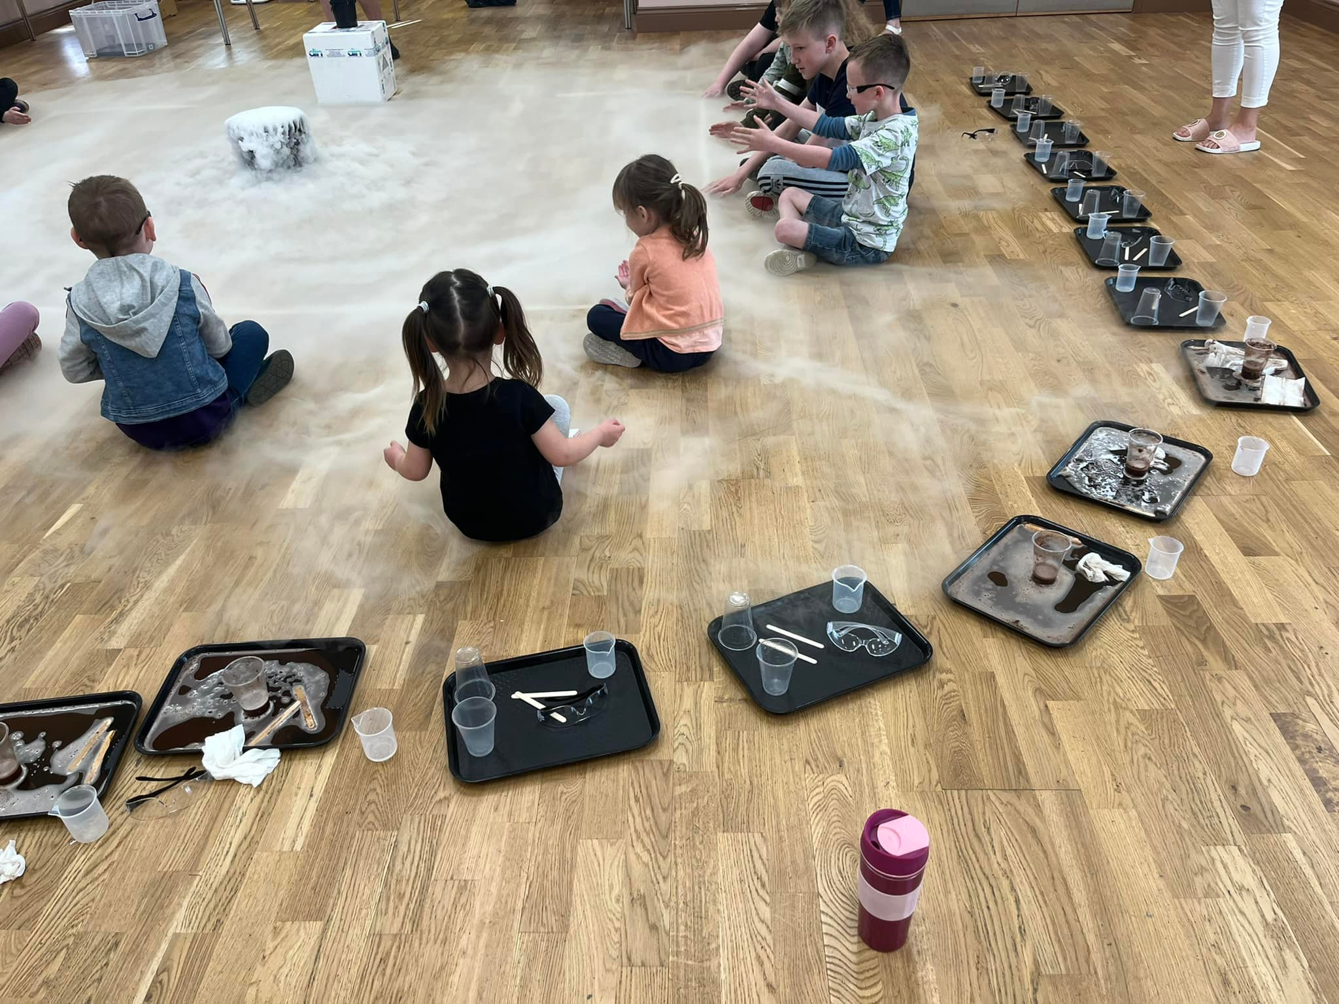

Big Science
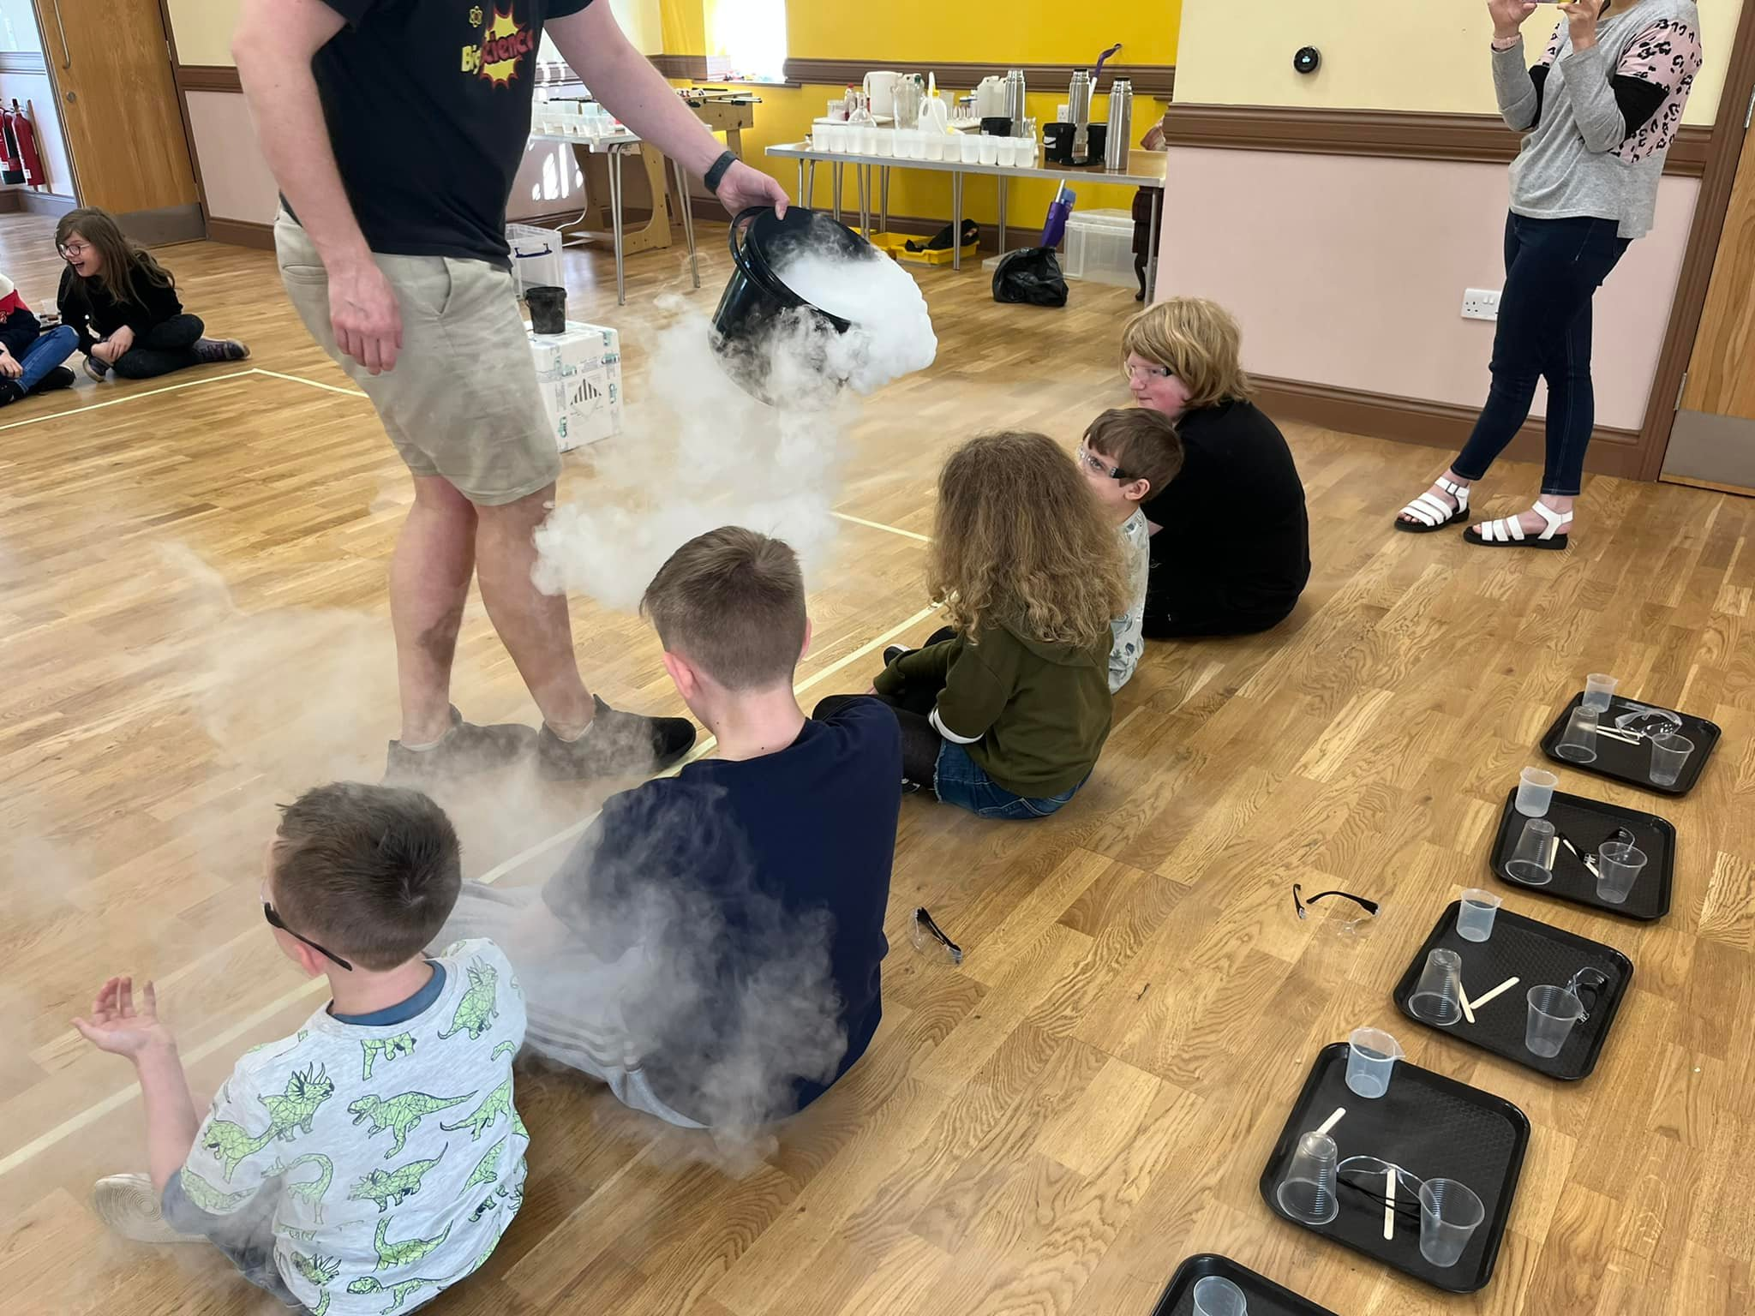

Big Science

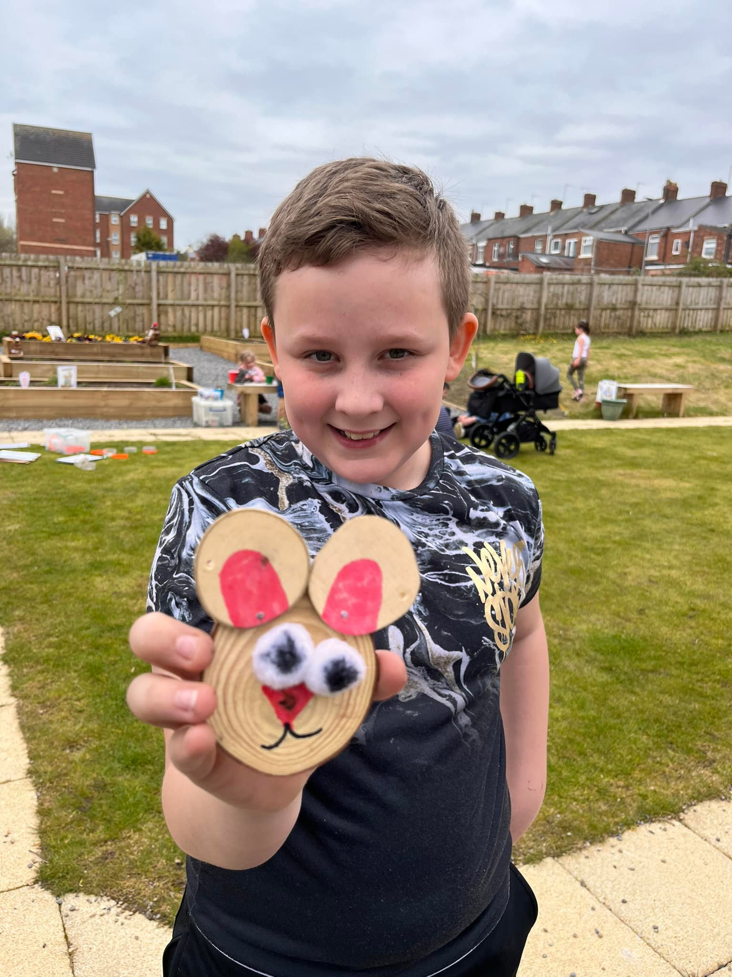

Noah Downlng Forest School
Alana Wallington Forest School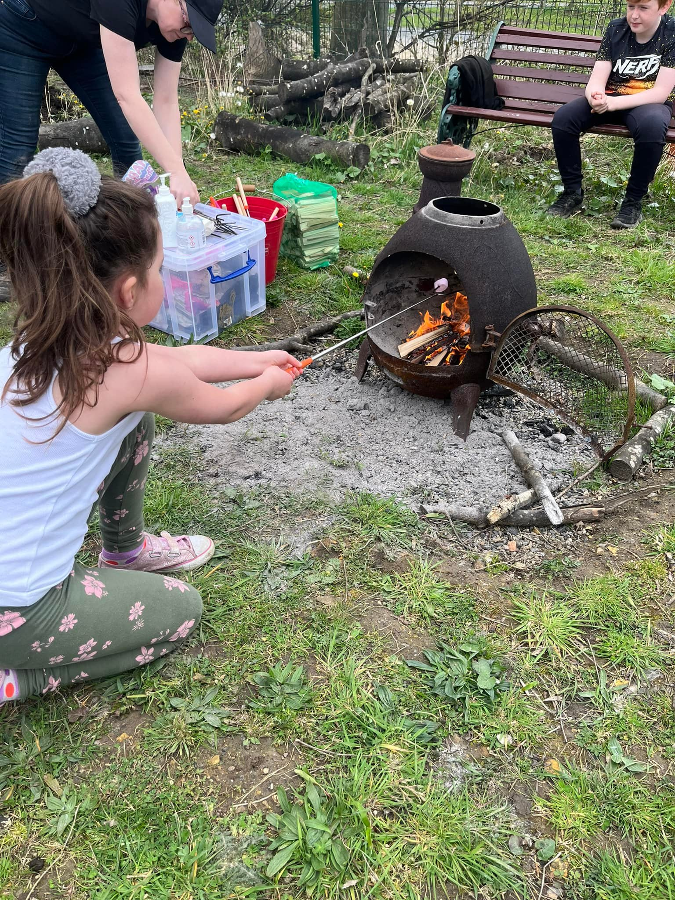

On Tuesday April 19th 40 children and adults spent an enjoyable afternnon at ROF39 at Newton Aycloffe follwed by food. This trip was funded by DCC Fun and Food scheme.

The children and some adults enjoyed tramppoling, swinging on ropes, jumping into foam and attempting the monkey bars.

Hudson “ bouncing was the best bit! I went so high that my feet nearly came over my head!!!”

Trampoling was so much fun it was very exhausting from Noah..... Trampoling was awesome! From Reuben

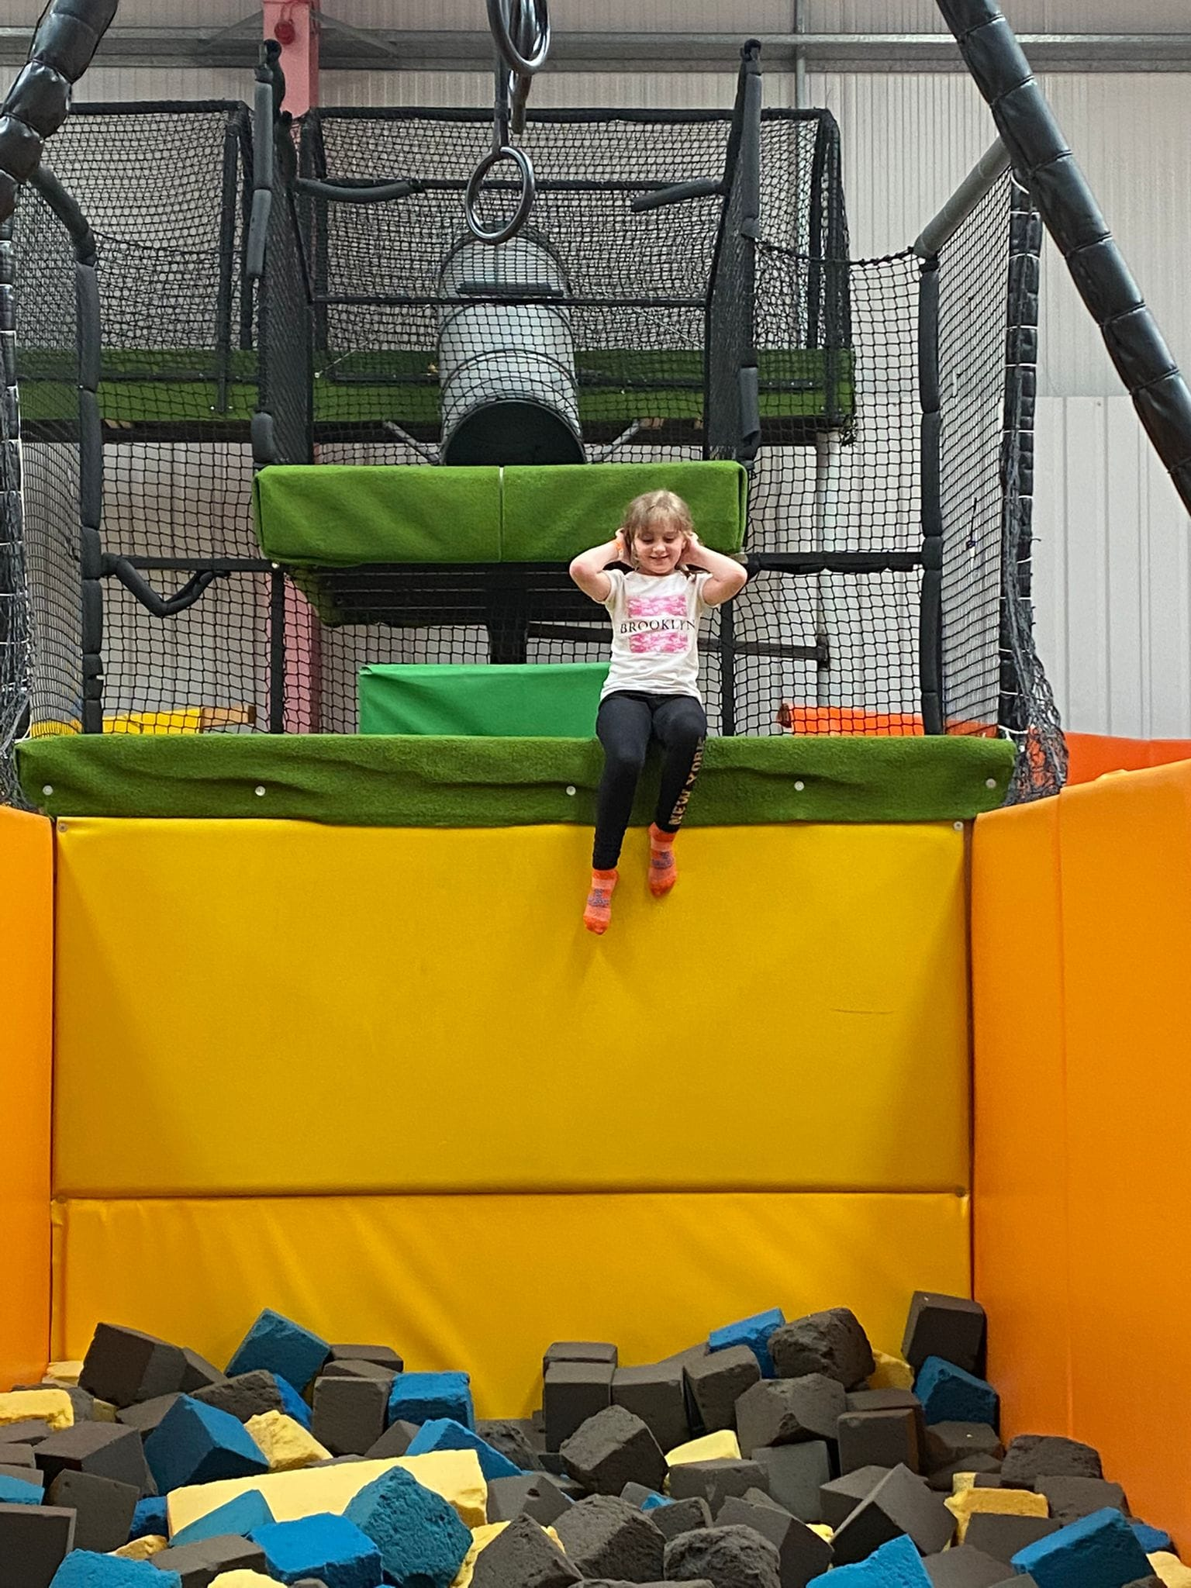
Hope Downing ROF 39

Reuban Downing ROF 39

